Software Development C++ Ifs – CHARACTER ANALYZER Lab Value - 50

Lab Goal : This lab was designed to teach you how to use if statements.

Lab Description : Ask the user to enter a digit 0-9, or a letter of the alphabet that is either upper or lower case. Analyze a character to determine if the character is lowercase, uppercase, or a digit. You must know the ASCII values for ‘a’, ‘A’, and ‘0’. You will need to use several nested if statements.

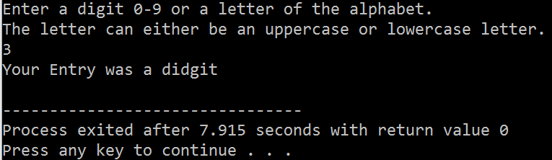

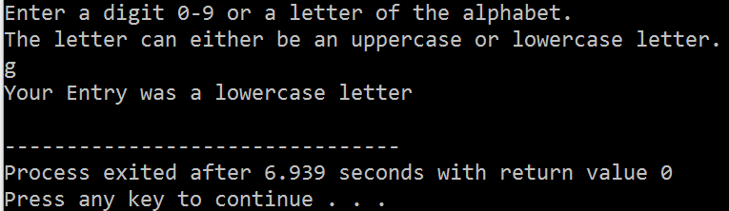

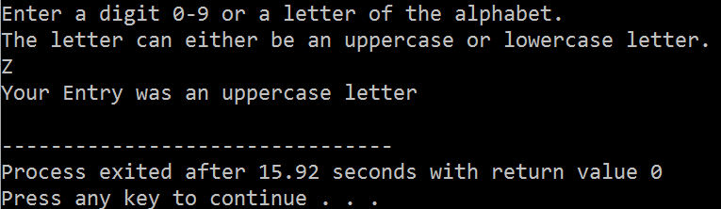

Testing Hint:

When testing your program it might be a good idea to test for 0, 9, a, z, A, and Z.

